Name : Prince Raj

Enrollment No. : A12405218012

Class : 5CSE13X

Q. Write a python program to sum all item in a list

Code and Output:

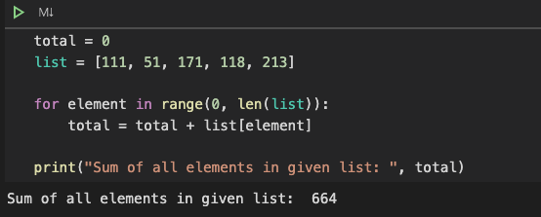

Q. Write a python program to get the largest number from list

Code and Output:

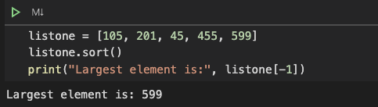

Q. Write a python program to get the smallest number from list

Code and Output:

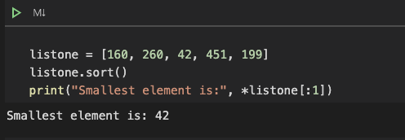

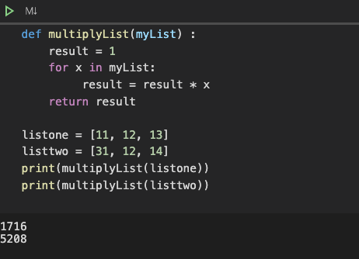Q. Write a python program to multiply all items from list

Code and Output: